System Architecture Flow
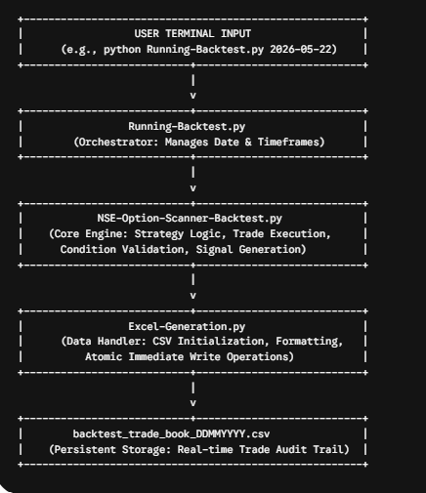
Updated File Logic:
- Filename Generation: Both NSE-Option-Scanner-Backtest.py and Excel-Generation.py now dynamically handle the filename based on the input date, converting it to the DDMMYYYY format (e.g., 22-05-2026 becomes backtest_trade_book_22052026.csv).
- Multi-Timeframe Support: Running-Backtest.py now uses argument parsing to execute your backtest logic across any number of timeframes you specify.
How to Run:
You can execute the backtest from your terminal by specifying the date and the timeframes (in minutes) you wish to scan:
# Run for a specific date across all default timeframes (1, 3, 5, 10, 15, 30, 1440)
python Running-Backtest.py 2026-05-22

# Run for a specific date with custom timeframes
python Running-Backtest.py 2026-05-22 --timeframes 5,15,30

